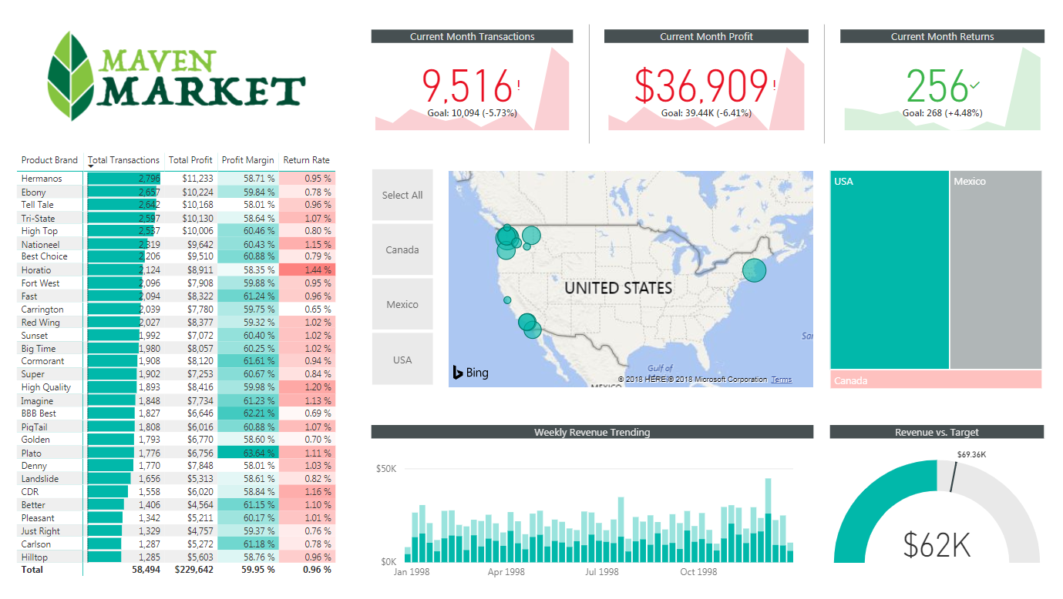

⭐ FULL INTERVIEW Q&A FOR YOUR MAVEN MARKET POWER BI PROJECT

✅ SECTION 1 — PROJECT STORYTELLING ANSWER (Use in Interviews)
“Walk me through your Power BI project.”
I built an end-to-end Power BI report using retail data from Maven Market.
I started by loading seven CSV files and a folder containing two years of transaction data. I performed data cleaning in Power Query — fixing data types, promoting headers, handling nulls, and creating calculated columns like full_name, birth_year, discount_price, price tier, and store full_address.
Next, I designed a proper star schema in Model View with lookup tables (Customers, Products, Stores, Regions, Calendar) and fact tables (Transaction_Data and Return_Data). All relationships were one-to-many and single-direction, ensuring filter context flowed correctly.
I then created more than 20 DAX measures, including Total Revenue, Total Profit, Profit Margin, YTD Revenue, 60-Day Rolling Revenue, Return Rate, and last-month KPIs using time intelligence.
Finally, I designed an executive Topline Performance dashboard with KPIs, a matrix for brand performance, map visual for geographic insights, weekly revenue trend charts, and a revenue-vs-target gauge. I also used bookmarks, slicers, conditional formatting, and drill-down functionality to enhance user experience.
The report highlighted key insights such as Portland passing 1,000 sales in December, the USA being the top revenue generator, and profit margin holding steady above 59%.

✅ SECTION 2 — TECHNICAL INTERVIEW QUESTIONS + PERFECT ANSWERS

🔷 DATA MODELING & POWER QUERY

Q1: How did you structure your data model?
✔ Answer:
I used a star schema. Lookup tables included Customers, Products, Stores, Regions, and Calendar. Fact tables were Transaction_Data and Return_Data. All relationships were one-to-many, with single-direction filtering.

Q2: Why did you disable “Autodetect new relationships”?
✔ Answer:
To avoid incorrect or redundant relationships. I manually created them so I maintained a clean, controlled, and optimized data model.

Q3: How did you clean and transform the data in Power Query?
✔ Answer:
I:
- Promoted headers
- Fixed data types
- Replaced nulls
- Added columns (full_name, birth_year, price tier, area_code, full_address)
- Combined two CSV files into a folder query
- Added date intelligence columns in Calendar

Q4: Why did you hide foreign keys in Report View?
✔ Answer:
To keep the field list clean for users and avoid accidental use of keys in visuals.

Q5: What is the purpose of the Calendar/LUT table?
✔ Answer:
To support time intelligence functions like YTD, last month, rolling windows, and filtering by months/weeks.

🔷 DAX MEASURES & CALCULATIONS

Q6: How did you calculate Total Revenue?
✔ Answer:
Using SUMX iterator for row-by-row multiplication:
Total Revenue =
SUMX(
Transaction_Data,
Transaction_Data[quantity] * RELATED(Products[product_retail_price])
)

Q7: How did you calculate YTD Revenue?
✔ Answer:
YTD Revenue =
TOTALYTD([Total Revenue], Calendar[date])

Q8: What is the difference between SUM() and SUMX()?
✔ Answer:
SUM aggregates a single column.
SUMX iterates through a table and performs row-level calculations — essential for revenue & cost.

Q9: Why did you create ALL Transactions and ALL Returns measures?
✔ Answer:
To show the grand totals regardless of filters, especially inside matrices.

Q10: How did you calculate the 60-day rolling revenue?
✔ Answer:
60-Day Revenue =
CALCULATE(
[Total Revenue],
DATESINPERIOD(Calendar[date], MAX(Calendar[date]), -60, DAY)
)

Q11: How did you calculate return rate?
✔ Answer:
Return Rate =
DIVIDE([Quantity Returned], [Quantity Sold])

🔷 VISUALIZATION & UX DESIGN

Q12: Why did you choose a matrix for product brand performance?
✔ Answer:
It allows comparison across multiple KPIs (transactions, profit, margin, return rate) in a compact format with conditional formatting.

Q13: What insights did the map and treemap visuals provide?
✔ Answer:
The map showed store-level geographic performance, while the treemap helped drill into countries → states → cities. USA dominated transactions.

Q14: What KPIs did you show and why?
✔ Answer:
- Current Month Transactions
- Current Month Profit
- Current Month Returns
The KPIs compare current month vs last month, showing business momentum.

Q15: Why did you use a Gauge chart?
✔ Answer:
To compare actual revenue vs target in a clean and intuitive way.

Q16: What insights did you bookmark?
✔ Answer:
- Portland exceeding 1,000 sales in December
- High return rates in specific brands
- Strong profit margin exceeding 59%
- USA outperforming Mexico and Canada

🔷 BUSINESS INSIGHTS

Q17: What were your top insights?
✔ USA generated the highest transactions.
✔ Profit margin was strong at ~60%.
✔ Portland hit 1,000 monthly sales in December.
✔ Weekend transactions were 28.4%.
✔ Return rate remained below 1%.

Q18: Which product brands performed best?
✔ Hermano, Ebony, Tell Tale — highest transactions & profit.

Q19: What improvement would you make if you had more time?
- Add forecasting
- Add customer segmentation
- Add drill-through pages
- Automate refresh via Power BI Gateway

✅ SECTION 3 — RESUME BULLET FOR THIS PROJECT
Copy & paste:
✔ Built an end-to-end Power BI analytics solution using the Maven Market retail dataset; created a star schema, cleaned 7+ data sources in Power Query, implemented 20+ DAX measures, designed executive dashboards, and delivered insights on revenue, returns, and store performance using KPIs, maps, matrices, bookmarks, and time-intelligence calculations.

🌟 1) FULL MOCK INTERVIEW (POWER BI PROJECT — 20 QUESTIONS + Model Answers)
I will play the interviewer.
Below each question is the ideal answer you should give.

🔹 INTRODUCTION & OVERVIEW

Q1: Can you briefly explain your Maven Market Power BI project?
A:
This was an end-to-end BI project where I cleaned and modeled multiple retail datasets, created a star schema, built 20+ DAX measures, and designed an interactive performance dashboard with KPIs, maps, trends, and bookmarks. The report analyzes transactions, revenue, profit, and returns across products, stores, regions, and time.

🔹 POWER QUERY / ETL

Q2: What steps did you take during data cleaning?
A:
- Promoted headers
- Fixed incorrect data types
- Replaced null values
- Combined multiple CSVs into one table using a folder query
- Created new columns such as full_name, birth_year, price tier, full_address, area_code
- Built a rich Calendar table with week, month, quarter, year, and weekend flag

Q3: Why did you disable Auto-Detect Relationships?
A:
Because Power BI often creates incorrect or redundant relationships. I wanted full control to ensure a clean, optimized schema.

🔹 DATA MODELING

Q4: Describe your data model.
A:
I used a star schema.
Lookup tables:
Calendar, Customers, Products, Stores, Regions.
Fact tables:
Transaction_Data and Return_Data.
All relationships were one-to-many and single-direction to ensure proper filter flow.

Q5: Why did you hide foreign keys?
A:
To reduce clutter and prevent end-users from dragging keys into visuals.

🔹 DAX & MEASURES

Q6: What measures did you create?
A:
More than 20 measures including:
- Total Revenue
- Total Cost
- Total Profit
- Profit Margin
- Return Rate
- Weekend Transactions
- YTD Revenue
- 60-Day Rolling Revenue
- Last Month Performance KPIs
- All Transactions / All Returns

Q7: How did you calculate Total Revenue?
Total Revenue =
SUMX(
Transaction_Data,
Transaction_Data[quantity] * RELATED(Products[product_retail_price])
)

Q8: Explain YTD Revenue.
YTD Revenue =
TOTALYTD([Total Revenue], Calendar[date])

Q9: What was the most challenging DAX measure?
A:
The 60-Day Rolling Revenue because it required date windowing with DATESINPERIOD and understanding filter context.

Q10: What is the purpose of using ALL()?
A:
I used ALL() to remove filters and calculate grand totals — useful in matrices for benchmark comparison.

🔹 VISUALIZATION & UX

Q11: Why did you use a matrix for product brands?
A:
It lets users compare multiple KPIs by brand (transactions, profit, margin, returns) in a compact way with conditional formatting.

Q12: What KPIs did you create?
A:
Current month transactions, profit, and returns — each compared to last month with a trend line and target.

Q13: Why use a map + treemap combination?
A:
The map shows spatial performance by city.
The treemap allows drill-down from country → state → city.
Together they support strong geographic analysis.

Q14: Why did you add bookmarks?
A:
Bookmarks help present insights like:
- Portland reaching 1,000 transactions
- Change across countries
- High/low margin products
They also let users jump to a Notes page for commentary.

🔹 BUSINESS INSIGHTS

Q15: What were your major insights?
- USA dominated transactions & revenue
- Profit margin stayed strong at ~60%
- Portland hit 1,000 sales in December
- Weekend transactions accounted for 28%
- Return rate was under 1%

🔹 DATA STORYTELLING

Q16: Who would use this dashboard?
Executives and regional managers who need quick visibility into store performance, profitability, and trends.

Q17: What decisions can be made from your report?
- Identify high-performing brands
- Spot cities that outperform or underperform
- Track revenue vs targets
- Manage product return issues

🔹 ADVANCED

Q18: How would you automate this in production?
A:
- Move the CSVs to a shared drive or cloud location
- Use a Power BI Gateway
- Schedule daily refresh

Q19: How would you improve the report?
- Add customer segmentation
- Add forecasting
- Add anomaly detection
- Add drill-through pages

🔹 CLOSING

Q20: Why is this project a strong example of your skill?
A:
It demonstrates complete BI lifecycle:
data cleaning → data modeling → DAX → UX design → insights → storytelling.

🌟 2) 60-SECOND VERSION — “Tell Me About Your Power BI Project”
I built a complete Power BI retail analytics solution using the Maven Market dataset.
I cleaned and transformed the data in Power Query, corrected data types, created calculated columns, and combined multi-year transaction files.
I then built a proper star schema with Customers, Products, Stores, Regions, and Calendar as lookup tables and two fact tables for transactions and returns.
Next, I created 20+ DAX measures including Total Revenue, Profit Margin, YTD Revenue, and rolling 60-day revenue.
Finally, I designed a Topline Performance dashboard with KPIs, a matrix of product brand performance, a geographic map, weekly revenue trends, and a revenue vs. target gauge.
The dashboard revealed insights such as USA being the top market, margins above 59%, and Portland exceeding 1,000 sales in December.
Overall, the project demonstrates my skills in data modeling, DAX, visualization design, and storytelling.

🌟 3) SCRIPT FOR PRESENTING YOUR PBIX TO RECRUITERS
Use this when screen-sharing your report.

INTRODUCTION
“Let me walk you through the Maven Market dashboard I created.
This project is designed to show end-to-end Power BI skills including cleaning, modeling, DAX, and storytelling.”

MODEL SECTION
“First, here’s the data model.
I used a clean star schema: Calendar, Customers, Products, Stores, and Regions are lookup tables.
Transaction_Data and Return_Data are fact tables.
All relationships are one-to-many and single-direction to ensure proper filter flow.”

DAX SECTION
“Next, I created 20+ DAX measures.
Revenue and cost use SUMX iterators because they require row-level calculations.
I also built Return Rate, Profit Margin, YTD Revenue, 60-Day Rolling Revenue, and last month KPIs.”

DASHBOARD SECTION
“This is the Topline Performance dashboard.
Here’s what it includes:
- KPI cards for transactions, profit, and returns
- Matrix breaking down brand performance
- Map of store transactions by city
- Treemap for drill-down from country to city
- Weekly revenue trend chart
- Gauge comparing revenue vs target
- Bookmarks to highlight insights”

INSIGHTS SECTION
“Some key insights:
- USA drives the majority of transactions
- Profit margin stays above 59%
- Portland exceeded 1,000 sales in December
- Weekend transactions make up 28%
- Return rate remains under 1%”

CLOSING
“This project shows my ability to handle the full lifecycle of Power BI development — from ingestion and cleaning to modeling, DAX, UX design, and business analysis.”

